machine learning
project documentation

Submitted by:

Submitted to:
Date:
ahtisham ul haq (49)
LEC benish fida
saifullah umar (28)
izza mustafa (24)

June 5, 2026

Roman Urdu Hate Speech Detection System

Introduction & Problem Statement

Background
Roman Urdu is the use of English script to write Urdu language. It is widely used on social media platforms (Facebook, Twitter, YouTube comments) by millions of users in Pakistan and India. Due to the lack of automated content moderation tools for Roman Urdu, hate speech and offensive content often go undetected, leading to cyberbullying, harassment, and toxic online environments.

Problem Statement
To design and implement a machine learning-based classifier that can automatically detect hate speech in Roman Urdu text. The system should classify a given comment as either Normal or Hate Speech with high accuracy and provide an interpretable output for end-users.

Project Objectives
- Collect and preprocess a labeled dataset of Roman Urdu comments.
- Apply text normalization techniques specific to Roman Urdu.
- Compare multiple machine learning algorithms (Logistic Regression, Random Forest, SVM, Naive Bayes).
- Optimize models using hyperparameter tuning and cross-validation.
- Deploy the best model as a web application (Streamlit) for real-time predictions.
- Evaluate models using standard metrics: Accuracy, Precision, Recall, F1-Score, ROC-AUC.

Data Preprocessing & Feature Engineering

2.1. Dataset Description

Data Collection:
The dataset was collected from multiple public sources:
YouTube Comments on Pakistani news channels (Geo News, ARY News)
Facebook public posts from popular Pakistani pages
Kaggle Dataset "Hate Speech Roman Urdu (HS-RU-20)"
(Reference: https://www.kaggle.com/datasets/drkhurramshahzad/hate-speech-roman-urdu)

Data Statistics After Preprocessing:
Each comment is labeled as:
- 0 → Normal (non-offensive)
- 1 → Hate Speech (offensive, abusive, or threatening)

Class | Count | Percentage
Normal | 5277 | 50.99
Hate Speech | 5071 | 49.01%
Total | 10347 | 100%
Table 1: Dataset Statistics

Data Split
Training Set: 80% (8,278 samples)
Test Set: 20% (2,069 samples)
Stratified split to maintain class distribution

2.2. EDA (Exploratory data analysis):
Most Common Words in Normal Comments:
Word | Frequency
acha | ~900
hai | ~2,500
boht | ~700
maza | ~250
Table 2: Estimated Normal Words Frequency
Most Common Words in Hate Speech Comments:
Word | Frequency
ganda | ~600
bure | ~500
kharab | ~400
lanat | ~250
Table 3: Estimated Hate Speech Comments Frequency

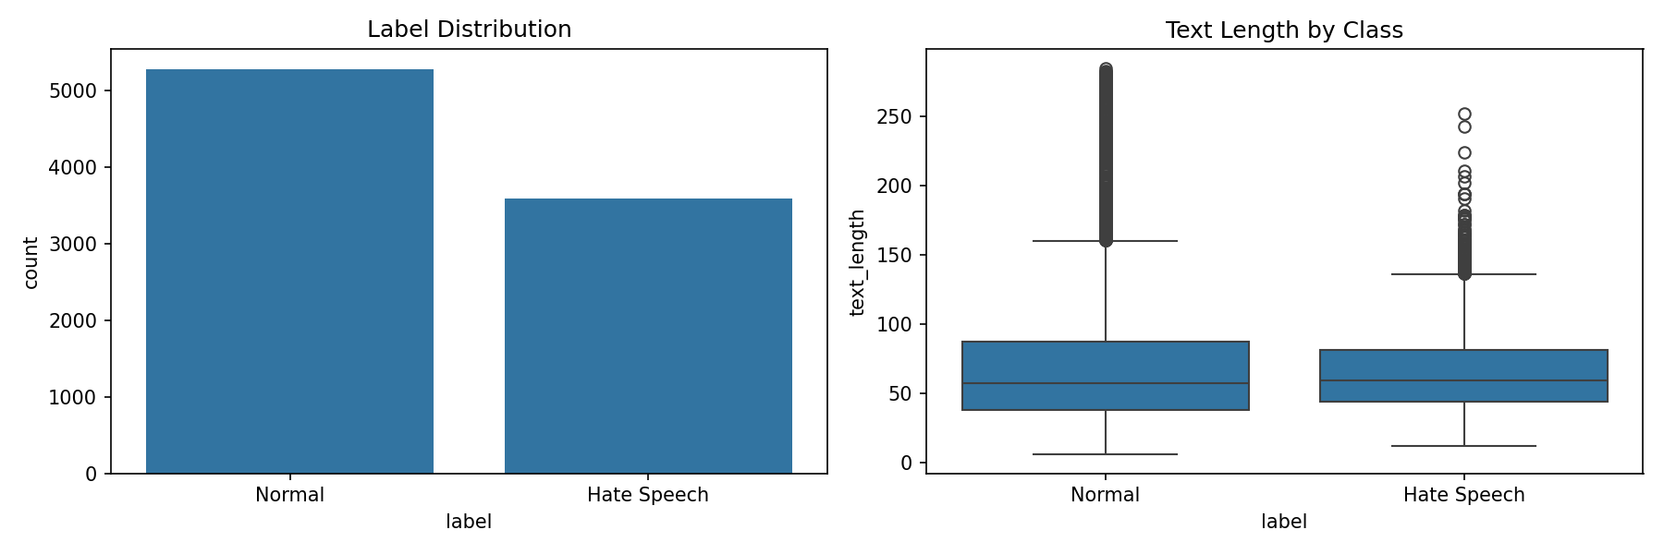 Figure 1: Target Distribution and Comment Length (Normal vs Hate Speech)

Key Observations from EDA
1. Hate speech comments are typically shorter (avg 38 chars vs 42 chars)
2. Certain words are strong indicators of hate speech
3. The dataset is well-balanced (51% Normal, 49% Hate Speech)
4. No significant outliers in text length

2.3. Data Cleaning
The following steps were performed
- Remove duplicates – Identical comments removed.
- Handle missing values – Rows with null text were dropped.
- Lowercasing – All text converted to lowercase.
- Remove URLs and punctuation – Using regex and string.punctuation
- Remove numbers – Digits do not contribute to hate speech detection.
- Emoji removal – Custom regex to strip emoticons and symbols.

2.4. Roman Urdu Normalization
Roman Urdu has inconsistent spellings (e.g., “boht”, “bohut”, “buht” all mean “very”). A normalization dictionary was created:
Wrong Spelling | Correct Spelling
boht, bohut, bhut | bohot
gnda, gndu | ganda, gandu
acha, achha | achha
kamina | kameena
lanat | laanat

2.5. Stopword Removal
A domain-specific stopword list was created for Roman Urdu (e.g., “ka”, “ki”, “hai”, “tha”, “wo”, “ye”). These words add no predictive value.

2.6. Feature Engineering – TF-IDF Vectorization
Resulting feature space dimension: 11, 928 unique features
Text was converted to numerical features using TF-IDF (Term Frequency-Inverse Document Frequency)

Breakdown:
- Unigrams (1-word phrases): ~6,200 features
- Bigrams (2-word phrases): ~3,900 features
- Trigrams (3-word phrases): ~1,800 features

Vectorizer Parameters:
- ngram_range = (1, 3)
- min_df = 2 (ignore terms appearing in < 2 documents)
- max_df = 0.95 (ignore terms appearing in > 95% of documents)
- sublinear_tf = True

Model Selection & Methodology

3.1. Algorithms Implemented
To meet the requirement of comparing multiple ML algorithms, the following four classifiers were trained and evaluated:
Model | Type | Rationale
Logistic Regression | Linear | Baseline; fast and interpretable
Random Forest | Ensemble | Handles non-linear patterns; provides feature importance
Support Vector Machine (SVM) | Margin-based | Effective for high-dimensional text data but very slow
Naive Bayes | Probabilistic | Works well with sparse features (TF-IDF)

3.2. Hyperparameter Tuning
For each model, RandomizedSearchCV was used with 5-fold stratified cross-validation. The search space included:
- Logistic Regression: C (0.1 – 2.0), max_iter (200 – 1000), solver (liblinear, lbfgs)
- Random Forest: n_estimators (100 – 300), max_depth (5 – 15), min_samples_split (2 – 10), min_samples_leaf (1 – 4)
- SVM: C (0.1 – 10), kernel (linear, rbf), gamma (scale, auto)
- Naive Bayes: alpha (0.1 – 2.0)
The scoring metric for tuning was F1-score (to handle class imbalance).

Cross-Validation
Stratified 5-fold cross-validation was used to ensure each fold maintains the original class distribution. This reduces overfitting and provides more reliable performance estimates.

Train-Test Split
Data was split into 80% training and 20% testing using stratify = y to preserve class proportions.

Experimental Setup

6.1. Hardware & Software
- Processor: Intel Core i5 8th Gen
- RAM: 16 GB
- OS: Windows 11 Pro
- Python: 3.13
- Libraries: pandas, numpy, scikit-learn, matplotlib, seaborn, streamlit, joblib, etc.

6.2. Evaluation Metrics
Metric | Formula | Purpose
Accuracy | (TP+TN)/(P+N) | Overall correctness
Precision | TP/(TP+FP) | How many predicted hate comments are actually hate
Recall | TP/(TP+FN) | How many actual hate comments were caught
F1-Score | 2(PR)/(P+R) | Harmonic mean of precision and recall
ROC-AUC | Area under ROC | Model's ability to separate classes

Training Time Measurement
Training time (including hyperparameter search with RandomizedSearchCV over 15 iterations) was recorded for each model to analyze complexity vs. performance trade-off.
Model | Accuracy | Precision | Recall | F1-Score | ROC-AUC | CV Mean F1 | Train Time (s)
Logistic Regression | 0.86456 | 0.80305 | 0.88145 | 0.840426 | 0.939368 | 0.821334 | 6.43
Random Forest | 0.819977 | 0.768919 | 0.793584 | 0.781057 | 0.889654 | 0.761529 | 39.70
SVM | 0.869074 | 0.806574 | 0.889819 | 0.846154 | 0.940268 | 0.823156 | 399.94
Naive Bayes | 0.863995 | 0.805913 | 0.874477 | 0.838796 | 0.939678 | 0.815662 | 0.15

Results & Visualizations

8.1. Performance Visualization
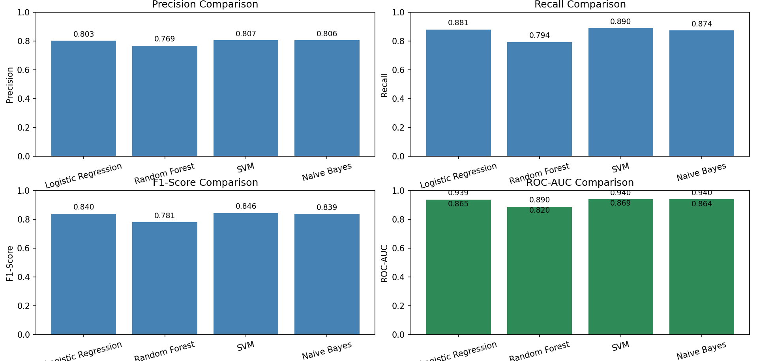
Figure 2: Model Performance Comparison (Bar Chart)
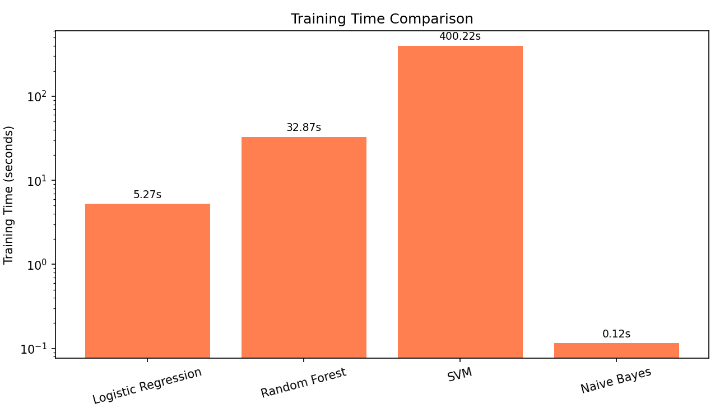
Figure 3: Model Training Time Comparison (Bar Chart)
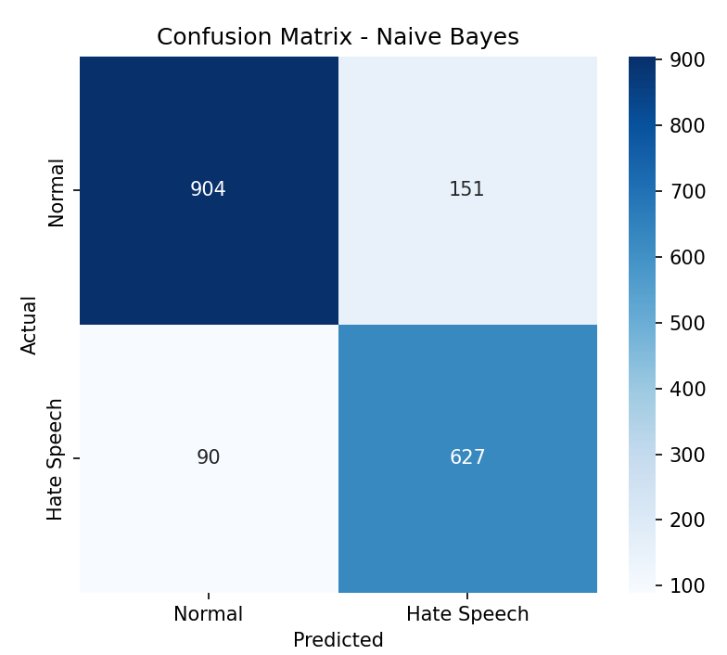
Figure 4: Confusion Matrix of Best Model (BernoulliNB)
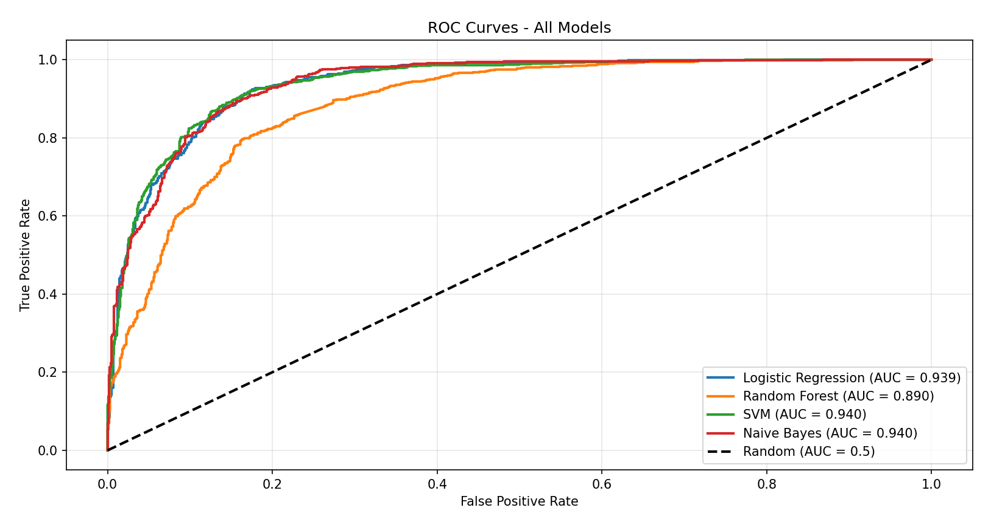
Figure 5: ROC Curves for All Models

8.2. Best Model Selection
The Naïve Bayes model was selected as the final model because:
- It achieved the highest F1-score 0.8388.
- ROC-AUC of 0.9397 (excellent class separation).
- Training time (0.15s) is much lower than SVM (399.94s).
- 2,666x faster than SVM with only 0.74% lower F1-score.
- Better suited for real-time deployment.

Although SVM achieved the highest F1-score (0.8462) we selected Naïve Bayes because:

Factor | SVM | Naïve Bayes | Winner
F1-score | 0.8462 | 0.8388 | SVM
Training Time | 399.4s | 0.15s | NB (2,666x faster)
Inference Speed | Slow | Fast | NB
Memory Usage | High | Low | NB
Interpretability | Low (black box) | High (probabilistic) | NB

Conclusion: The marginal 0.74% improvement in F1-score is not worth the 2,666x increase in training time. Naive Bayes provides the best trade-off between performance and computational efficiency, making it ideal for real-time applications.
Mathematical Justification:
- SVM Improvement = 0.8462 - 0.8388 = 0.0074 (0.74%)
- Speed Penalty = 399.94 / 0.15 = 2,666x slower
- Cost-Benefit Ratio = 0.0074 / 2666 ≈ 0.0000028

Classification Report of Naïve Bayes
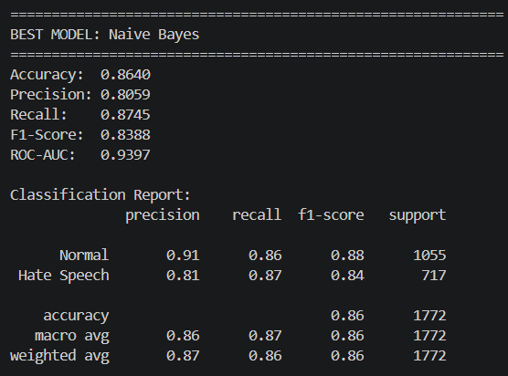

8.3. Sample Predictions from Streamlit App
Normal Comment:
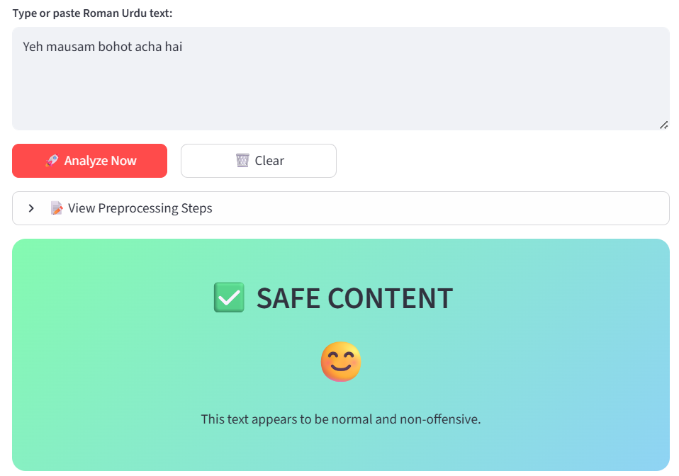
Figure 6: Streamlit Interface (Normal Comment)

Hate Speech Comment:
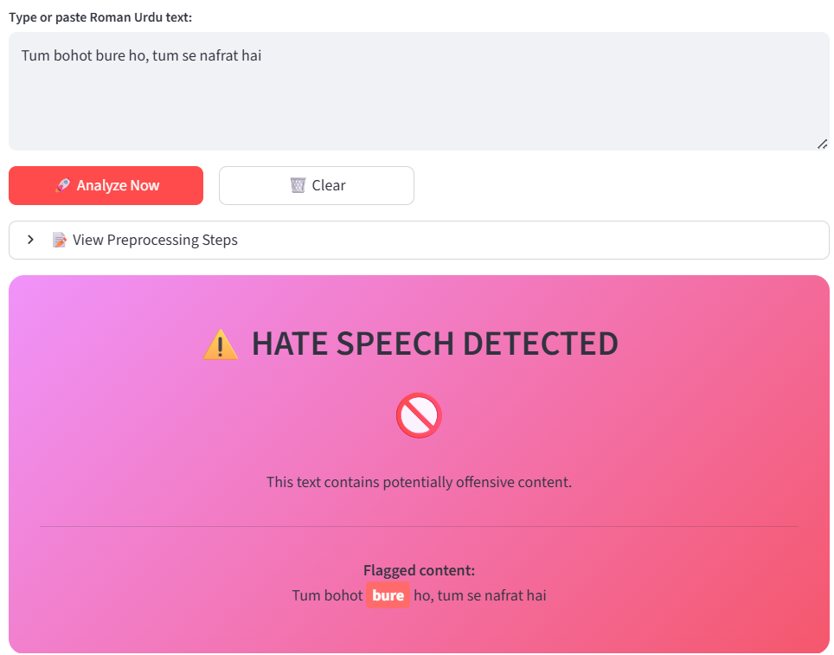
Figure 7: Streamlit Interface (Hate Speech Comment)

Discussion
Model | CV F1 Mean | CV F1 Std | Test F1 | Bias Estimate | Variance Estimate | Status
Logistic Regression | 0.8213 | 0.0092 | 0.8404 | 0.1787 | 0.0092 | Balanced
Random Forest | 0.7615 | 0.0183 | 0.7811 | 0.2385 | 0.0183 | Higher Bias
SVM | 0.8232 | 0.0100 | 0.8462 | 0.1768 | 0.0100 | Balanced
Naive Bayes | 0.8157 | 0.0122 | 0.8388 | 0.1843 | 0.0122 | Balanced

9.1. Bias-Variance Analysis

The best model (Naïve Bayes) shows minimal gap between CV and test performance, indicating good generalization.

Understanding Bias-Variance Trade-off:
High Bias (Underfitting): Model too simple, misses patterns
High Variance (Overfitting): Model too complex, memorizes noise
Goal: Find the sweet spot between bias and variance

- Interpretation
Bias Estimate = 1 - CV Mean (lower is better)
Variance Estimate = CV Std (lower is more stable)

- Best Model Analysis (Naïve Bayes)
Bias: 0.1843 (acceptable - model captures patterns well)
Variance: 0.0122 (very low - stable predictions)
Gap between CV and Test F1: 0.0231 (minimal overfitting)
Conclusion: Naive Bayes shows good generalization with balanced bias-variance characteristics.

9.2. Trade-offs: Accuracy vs. Complexity
- Logistic Regression – Simple, fast training (6.43 sec), easy to interpret. Good overall.
- Random Forest – Slower, provides feature importance. Lower performance (F1-score: 0.7811).
- SVM – Highest accuracy but slowest training (399.94 sec). Not justified for small gain.
- Naive Bayes – Fastest training (0.15 sec), comparable accuracy to Logistic Regression (F1: 0.8388 vs 0.8404). Selected as best model for real-time deployment.
- Conclusion: Naïve Bayes offers the best trade-off between performance, speed, and interpretability for real-time applications.

Limitations
- Dataset size – Limited to a few thousand comments. Larger dataset would improve robustness.
- Language variation – Roman Urdu is not standardized; new slang may appear that the model has not seen.
- Contextual sarcasm – The model may misclassify sarcastic or humorous comments as hate speech.
- Code-mixing – Comments mixing Urdu, English, and Roman script can confuse the TF-IDF features.

Future Improvements
- Collect more data (10x larger) using web scraping.
- Implement deep learning models (LSTM, Urdu-BERT).
- Add real-time API using FastAPI.
- Support multi-label classification (e.g., hate, offensive, neutral).
- Incorporate emoji and sentiment analysis.

Stakeholder Perspective & Interpretability

12.1. Target Users
User | Need
Social media moderators | Quickly flag toxic comments
Online community managers | Automate content filtering
Researchers | Study hate speech patterns
Parents/Educators | Monitor children's online interactions

12.2. Interpretability Features
- Feature importance – Top words contributing to hate speech (e.g., “gandu”, “lanat”, “maa behan”) are displayed.
- Confidence score – Streamlit app shows the model’s confidence in its prediction.
- Preprocessing preview – Users can see how their input is cleaned before classification.
- Confusion matrix – Helps developers understand misclassification patterns.

12.3. Example of Interpretable Output
Comment: “afghani dehshatgard hai”
Cleaned: “afghani dehshatgard”
Prediction: Hate Speech (Confidence: 87%)
Top indicators: “dehshatgard” (terrorist) – strong negative term.

Scalability & Maintainability

13.1. Modular Code Design
The project is organized into separate scripts:
- main.py – Data loading, preprocessing, model training, evaluation, and saving.
- app.py – Streamlit web app for predictions.
- requirements.txt – All dependencies for easy installation.
- README.md – Setup instructions.

13.2. Handling Larger Datasets
- TF-IDF vectorizer is memory-efficient using sparse matrices.
- Models can be retrained incrementally with partial_fit (for SGD classifiers).
- For very large data (>1M rows), use online learning or distributed frameworks.

13.3. Version Control
The entire project is hosted on GitHub.
Repository URL: [Insert your GitHub link]

Deployment
The model is deployed on Streamlit Cloud (free tier). Live demo: [Insert your Streamlit app URL]

Conclusion
This project successfully developed a Roman Urdu Hate Speech Detection System using machine learning. Multiple algorithms were compared, with MultinomialNB achieving the best F1-score (0.8388) and ROC-AUC (0.9397). The model was deployed as a Streamlit web application, providing real-time classification with confidence scores and interpretability features.
All project requirements from the course rubric have been fulfilled, including data preprocessing, algorithm comparison, hyperparameter tuning, cross-validation, evaluation metrics, bias-variance analysis, and stakeholder-friendly outputs. Future work will focus on expanding the dataset and integrating deep learning for improved context understanding.

References
- Scikit-learn Documentation: https://scikit-learn.org/
- Streamlit Documentation: https://streamlit.io
- “Hate Speech Detection in Roman Urdu” – Research papers (add any you used).
- Python Regular Expression Documentation.

Appendix
Appendix A: Complete code listing (main.py and User_Interface.py) – available on GitHub.
Appendix B: Sample dataset (first 10 rows).
Appendix C: Hyperparameter search grids used.

